Week 1-4

- pow(a,b,c)就是(a**b)%c
- from math import sqrt(), cos(), sin(), exp(), sinh(), log(), atan()等. note that log means “logarithm to the base e”
- from cmath import sqrt(), cos(), sin(), exp(), sinh(), log(), atan()等以允许复数运算

- int1 / int2 returns an approximate decimal (actually what we’re now calling a float).
- int1 ** int2 returns the exact value of the rather hefty integer. Python neither tries to round this number nor reports an error.
- float1 ** float2 returns the standard form of the result. Python is rounding, and representing the number in “scientific notation”. Also, you’ll get an overflow error if the result is too big: Python allows ints of arbitrary size, but for floats there’s a size limit
- Complex number is defined as:
comp1 = <number> + <number> * 1j
comp2 = complex(<number>,<number>)
comp1.real and comp1.imag all return float.

So that’s one difference: tuples are like lists except you can’t append to them. If we wanted
to solve this problem, we’d need to do something like this:
tuple1 = tuple1 + (<new contents>)
(Note in passing that if we want a tuple with one element, like the tuple containing just
'x', we need to type ('x',) )

Python has a feature called string formatting.
template = <string consists of {}>
template.format(<elements we want to fill in>)
And here’s the modern, readable way to do it, using what’s called a formatted string literal(or f-string for short):
template = f‘<string consists of {}, and elements we want to fill in are in {}>’

Suppose you have two collections of data in the form of sequences (lists or tuples, for
example), and they’re the same length, and the data items correspond in some way. You
may want to combine them into a single collection consisting of paired data. One neat way
to do this is using the zip function.
combined = zip(xvals,yvals)
We can get access to the contents by converting this object into a list or a tuple; we see
that its contents consist of 2-tuples.
print(list(combined))

The structure of a for loop is always
for x in <something>:
<do a thing>
It’s possible to write for loops over include:
ranges; lists; tuples; strings; count objects; islice objects; zip objects.

Comprehensions are appropriate when you start with an iterable sequence, and want to do the same thing to each of its elements, ending up with a list.
[<some results> for x in <something> if <some conditions>]
Week 5-6

lambda-expressions are a way of referring to functions
lambda x: <a mathematical function of x>

If you want to equip your own function with default arguments, there’s only one rule:
any ordinary non-default arguments have to be listed first.
def <function_name>(arg1, arg2, ..., *, default_arg_a = A, default_arg_b = B, ...):
<code>
return <value>
But here, default_arg_a, default_arg_b and so on are now strictly keyword-only arguments. If you want to change them in the future imported function, write:
<imported function>(..., default_arg_a = ..., default_arg_b = .., ...)

方法会在return后停止运行, 因此, 我们可以在方法中使用While True, 但是一定要确保有最终输出:
While True:
<do something>
If <condition>:
return <result>

So far, when we’ve wanted Python to do the same thing over and over again, we’ve written a loop, using either while or for: this is called iteration. There exists an entirely different approach, called recursion, which works by getting a function to call itself: that is, by having the function’s code include the function itself.
def <recursive_function>(arg1, arg2, ...):
<code>

# base case
if <base_condition>:
return <base_value>

# recursion step
else:
<code>
return <recursive_function>(<changed_args>)

Week 7

If you base your array on a list of lists, it will end up two-dimensional, like a matrix
import numpy as np
array1d = np.array([0,1,2]) # [0. 1. 2.]
array2d = np.array([[1,0,0],[0,1,0],[0,0,1]]) # [[1. 0. 0.]
- 1. 0.]
- 0. 1.]]

It’s often useful to have an array all of whose elements are equally spaced.
We can either use the linspace function, which allows us to specify the first value, the last value and the number of values.
Or the arange function, which allows us to set up a range of values--a little like the
range function, except that the step size is allowed to be a float.
from math import pi
import numpy as np
array1 = np.array([i * pi/6 for i in range(13)])
array2 = np.linspace(0, 2*pi, 12)
array3 = np.arange(0, 2*pi+0.1, np.pi/6)
Notice that arange obeys the standard Python system: it delivers those numbers, in steps of π/6, that are greater than or equal to zero but strictly less than 2π+ 0.01. For this reason,
array4 = np.arange(0, 2*pi, np.pi/6)
wouldn’t have worked.

It may not be immediately obvious why, but it turns out to be really useful to be able to
create NumPy arrays consisting entirely of 0s or 1s.
np.zeros(5) # [0. 0. 0. 0. 0.]
np.ones(5) # [1. 1. 1. 1. 1.]
np.zeros([3,4]) # [[0. 0. 0. 0.]
[0. 0. 0. 0.]
[0. 0. 0. 0.]]
np.ones([2,6]) # [[1. 1. 1. 1. 1. 1.]
[1. 1. 1. 1. 1. 1.]]

By default, float values are used; but this can be overridden to create arrays of ints, complexes, or even Booleans
np.ones(5, dtype='bool') # [True True True True True]

If two arrays are the same shape, it’s possible to add them, and they’ll add component-by-component. it turns out it’s also possible to use all the other arithmetic operators on arrays as well: -, *, /, // and **
It’s also possible to use all the arithmetical operations on a NumPy array and a scalar. At that time, each component is operated with the scale
除此之外, 我们还可以让m行n列的2d array与1行n列的2d array进行运算(注意: 必须按照2d array的格式写入).

NumPy supports a comprehensive selection of linear algebra functions and methods. 1D
arrays can be used to represent vectors:
np.dot(vec1, vec2)
np.cross(vec1, vec2)
and 2D arrays can be used to represent matrices:
np.dot(mat1, mat2)

The basic linear algebra functions dotand crosslive in the top level of NumPy; for anything even a bit more specialised, you need the linalg submodule.
import numpy.linalg
np.linalg.det(mat1)
np.linalg.inv(mat1)

NumPy has a collection of functions for dealing with the algebra of polynomials, which are represented by a special kind of array called poly1d. These arrays consist of the coefficients in the polynomial, in descending power order.
It can also calculate roots, and substitute in values, differentiate and integrate, and so on.
poly1 = np.poly1d([1, -3, 2]) # $x^{2}$-3x+2
np.roots(poly1) # [1. 2.]
np.polyval(poly1, [1, 3, 5, 7]) # [ 0 2 12 30]
np.polyder(poly1) # 2x-3
np.polyint(poly1) # $\frac{1}{3}x^{3}$-$\frac{3}{2}x^{2}$+2x

Week 8

import random as rnd
rnd.random() # 返回一个0到1之间的数(inclusive)
rnd.randint(Start, Stop) # 返回一个在Start和Stop之间的整数(inclusive)
rnd.randrange(Start, Stop, Step) # 返回一个在范围内的整数(包括Start但是不包括Stop)
rnd.choice(List) # 返回一个List中的元素
rnd.choices(List, weights = List_of_Weight, k=K)
# 放回抽取List中的元素, 抽K次, 每个元素的权重由List_of_Weight决定
rnd.sample(List, k=K) # 不放回抽取List中的元素, 抽K次,

rnd.uniform(a, b)
rnd.normalvariate(mean, sd)

import numpy.random as nrnd
nrnd.random(Size)
#返回一个由size决定的array, 内容为0到1之间的数(inclusive)
nrnd.randint(Start, Stop, Size)
# 返回一个size决定的array, 内容为在Start和Stop之间的整数(inclusive)
nrnd.choice(Array, K, replace=True) # 放回抽取Array中的元素, 抽K次
nrnd.choice(Array, K, replace=False) # 不放回抽取Array中的元素, 抽K次
nrnd.permutation(Array) # 返回一个重排后的结果, 不改变原Array
nrnd.shuffle(Array) # 对原Array进行重排, 改变原Array
Note that the returned values are NumPy ints, which means they’re not allowed to be of
arbitrary size.

nrnd.normal(mean, sd, Size)
nrnd.binomial(n, p, Size)
nrnd.poisson(λ, Size)

Array = np.append(Array, Value, axis=None)
# 不写axis则默认扁平化拼接, Array和Value被扁平化为一维数组. 当axis=0表示按行拼接, axis=1表示按列拼接, 此时要求Array和Value在其他轴的纬度一致. 不会自动覆盖.
Array = np.concatenate(Array, Value, axis=0)
# 当axis=0表示按行拼接, axis=1表示按列拼接, 此时要求Array和Value在其他轴的纬度一致. 不会自动覆盖.

x_output, y_output = np.meshgrid(x_values, y_values)
# 输入2个一维数组, 组成一个二维平面网络, 然后输出2个二维数组, 其中x_output取二维平面网络的每一个元素的第一个元素, y_output取每一个元素的第二个元素.

import matplotlib.pyplot as plt
plt.figure(figsize=(宽, 高), dpi=分辨率, facecolor=背景色)
plt.subplot(行数, 列数, 序号)
plt.title(标题, fontsize, fontweight)
plt.xlabel(X轴标签, fontsize)
plt.ylabel(Y轴标签, fontsize)
plt.legend(loc=‘best’, fontsize=10, frameon=True)

# 折线图
plt.plot(x, y, color=颜色, linestyle=线型, linewidth=线宽, marker=标记,
markersize=标记大小, label=图形标签)
# 标记: '.'点, 'o'圆圈, 's'方形, '*'星号
# 线型: '-'实线, '--'虚线, ':'点线, '-.'点划线

# 散点图
plt.scatter(x, y, s=大小, c=颜色, marker=标记, alpha=透明度)

# 柱状图
plt.bar(x, height, width, color, edgecolor)
plt.barh(y, width, height, color, edgecolor)

# 直方图
plt.hist(data, bins=分组边界值(区间是左闭右开的), color, edgecolor)

# 饼图
plt.pie(sizes=数值数组, labels=每个数组的标签)

# 矩阵可视化
plt.imshow(Array, origin=原点位置)
plt.matshow(Array, origin=原点位置)

# 等高线
plt.contour(x=二维数组的每个元素的第一个元素, y=二维数组的每个元素的第二个元素,
z=二维数组的每个元素的对应数值)

# 3D投影
from mpl_toolkits.mplot3d import Axes3D
ax = plt.axes(projection='3d')
ax.plot_wireframe(x, y, z)
ax.plot_surface(x, y, z)
ax.contour(x, y, z)

# vector field plot
plt.quiver(X, Y, dzdx=对应的二维数组, dzdy=对应的二维数组)

Week 9

1D NumPy arrays use the same indexing and slicing conventions as lists and tuples.
Multi-dimensional arrays can be indexed using a comma notation:
mat1 = np.array([[2, 3, -2], [1, -5, 0], [-2, 1, 2]])
mat1[0,1] # 3
mat1[2,0:2] # [-2 1]
Arrays are mutable, like lists, as opposed to being immutable, like tuples. You can change individual elements:
arr3 = np.array([3, 5, 2, 1, 9, 4])
arr3[2] = 100
arr3 # [ 3 5 100 1 9 4]

Array = np.append(Array, Value, axis=None)
# 不写axis则默认扁平化拼接, Array和Value被扁平化为一维数组. 当axis=0表示按行拼接, axis=1表示按列拼接, 此时要求Array和Value在其他轴的纬度一致. 不会自动覆盖.
Array = np.concatenate(Array, Value, axis=0)

Just like lists and tuples, arrays can be iterated over.
We can even iterate across multidimensional arrays, using a NumPy function called nditer. Note that in this case, Python has iterated along the rows one by one.
It’s even possible to use nditer to iterate across two arrays at the same time
for n in Array1D:
...
for n in np.nditer(ArrayND):
...
for m, n in np.nditer((Array1, Array2)):
...

There’s a NumPy function called fromfunctionthat allows you to generate an n-dimensional array of floats using a function of n variables.
def twoxplusy(x, y):
return 2*x+y
np.fromfunction(twoxplusy, (3, 2)) # [[ 0., 1., 2.,],
[ 2., 3., 4.,]]
np.fromfunction(lambda x, y: 2*x+y, (3, 2)) # [[ 0., 1., 2.,],
[ 2., 3., 4.,]]

what’s undeniable is that for long programming tasks this vectorized approach tends to be much, much more efficient. vectorization only works when you want to do the same thing to every element of a data structure

This is what’s called a Boolean array. 可以通过比大小/等于号得到.
~(statement) # 求逆
如果我们只要array中为True的项:
Array[Boolean_Array]

Week 10

from sympy import sp
sp.init_printing() # 开启美观的表达式打印功能
开启表达式打印功能之后, 我们通过sp得到的值都是exact quantity, 用分数/开根等表示.
sp.sin(sp.pi/3), sp.atan(1), sp.exp(sp.log(7))) # $\frac{\sqrt{3}}{2}$, $\frac{π}{4}$, 7
we can convert the exact quantity to a core Python float by using float(), or we can use a method called evalf to evaluate it as a float to arbitrary precision:
x.evalf(n) # 保留n位有效数字

SymPy has its own version of most of the mathematical functions and constants you’d fine in NumPy or math; however, by default, most of them return exact values.

创建分数的两种方法:
sp.Rational(a, b) # 输出$\frac{a}{b}$

num = sp.Integer(a)
den = sp.Integer(b)
num/den # 输出$\frac{a}{b}$
rationals behave sensibly under the main arithmetic operations

the SymPy module contains its own implementation of complex numbers, sp.I.
进行复数计算时, sympy会保留I的m次方的形式. 为此, 我们使用sp.expand(x)展开函数.
z1 = 3 + 4*sp.I
z1**2 # 9 + 24i + 16i²
z2 = sp.expand(z1**2) # −7 + 24i
sp.expand() 的作用是:
- 把幂运算, 乘积等紧凑形式展开为逐项相加/相减的多项式形式.
- 自动处理虚数单位 sp.I 的运算(比如 i² = -1).
- 展开普通多项式, 三角函数等.

x, y = sp.symbols('x y') # let x and y be variables whose values are the symbols x and y

expr = x + 2*y**2 # symbolic expression. expr的输出是x+2y²
expr - x + y**2 # 输出是3y²
sp.expand(expr**3) # ${展开函数, 输出是x}^{3}$+6$x^{2}y^{2}$+12x$y^{4}$+8$y^{6}$

expr = x**3 + 6*x**2*y**2 + 12*x*y**4 + 8*y**6
sp.factor(expr) # factorise函数. 输出是${(x+2y²)}^{3}$

expr = 1/((x+2)*(x+1))
sp.apart(expr) # partial fraction函数. 输出是-$\frac{1}{x+2}$+$\frac{1}{x+1}$

expr = (x+1)**4 - (x-1)**4
sp.simplify(expr) # simplify函数. 输出是8x($x²+1$)

We can use substitution函数计算单个或多个数值大小, 或者是进行symbolic substitution.
x, y = sp.symbols('x y')
expr = 16*x**5 - 20*x**3 + 5*x
f = sp.lambdify(x, expr)
f(2) # 输出是362
expr.subs(x, 2) # 输出是362
f(y**2) # 输出是$16y^{10}−20y^{6}+5y^{2}$
expr.subs(x, y**2) # 输出是$16y^{10}−20y^{6}+5y^{2}$

import numpy as np
fn = sp.lambdify(x, expr, 'numpy')
fn(np.arange(-3,4)) # 输出是 array([-3363, -362, -1, 0, 1, 362, 3363])
fn(y**2) # 输出是$16y^{10}−20y^{6}+5y^{2}$.
# NumPy-compatible lambda-expression still works with symbols

比较多个function是否相同
- The operator== is very strict: it only returns True if two expressions are, once they’ve undergone a standard rearrangement, exactly the same.
expr1 == expr2
- A more generous test of whether two expressions are equivalent is to see if their difference simplifies to give zero, but it also fails sometimes.
sp.simplify(expr1-expr2)==0
- There’s something called the equals method.
expr1.equals(expr2)
- The fourth kind of equality is quite distinct, and arises when you don’t want to test whether two quantities are equal, but simply to set up an equation, perhaps in order to solve it.
sp.solve(sp.Eq(expr1,expr2), x) # 当expr1和expr2结果相等时, x的取值

def deriv_val(expr, x, a):
from sympy import diff
dexpr = diff(expr, x) # 求导函数.
return dexpr.subs(x, a)
deriv_val_vec = np.vectorize(deriv_val) # 矢量化函数.
deriv_val_vec((x+1)**4 - (x-1)**4, x, np.arange(-3,4))
# 输出 array([224, 104, 32, 8, 32, 104, 224], dtype=object)

sp.Matrix([[1, 2], [2, 2]]) # 创建矩阵
以下函数可以使用:
m * m, m ** 2, m.det(), m.inv(), m.eigenvals(), m.eigenvects()

用sp画图的比较:
sp.plot(sp.sin(x), (x, 0, 2*sp.pi))

p = sp.plot(sp.sin(x), sp.cos(x), (x, 0, 2*sp.pi), show=False)
p[0].line_color = 'red'
p[1].line_color = 'blue'
p.show()

import sympy.plotting as splt
p_add = splt.plot_parametric(sp.cos(3*t), sp.sin(5*t), (t, 0, 2*sp.pi))
# parametric function画图, 记得引入新的库
p.extend(p_add) # 整合
p.show()

Week 11

More generally, if f(n) is a function so that, under worst case assumptions, the number of operations in a task of size n is asymptotically equal to a multiple of f(n), we write that the algorithm is O(f(n)). This is, unsurprisingly, known as big O notation.
By contrast, the best-case complexity is represented using big Ω notation.
When the values for both big O notation and big Ω notation are the same, we use big Θ notation.

Lists and sets are what we call mutable: you can change them piecemeal. By contrast, tuples and strings are immutable.
Frozen = frozenset(Mutable) # 将mutable元素转为immutable:
from copy import copy
List1 = copy(List2) # 保证所对应的List本质上不相同.
# 因为对于mutable的元素A, 让B=A, 改变A时B也改变. 而对于immutable的元素C, 让D=C, 改变C时D不变

F1 = open("file.txt", "w")
F1.write(str(Dictionary1))
F1.close()

F2 = open("file.txt", "r")
Str = F2.read()
F2.close()
Dictionary2 = eval(Str)

import pickle

F1 = open("file.txt", "wb")
pickle.dump(Dictionary1, F1)
F1.close()

F2 = open("file.txt", "r")
Dictionary2 = pickle.load(F2)
F2.close()

我们甚至可以直接阅读文件中的代码, 然后直接导入进行操作
note the use of the triple-quote to break the long string over several lines, and the use of the special
character \n to represent a line break in the code
Code = """...""" # 注意用\n进行分段

F1 = open("file.txt", "w")
F1.write(Code)
F1.close()

F2 = open("file.txt", "r")
Operation = F2.read()
F2.close()

exec(Operation)

Week 12

A pandas Series is in some respects a little like a dictionary: it consists of index keys and values.
Series1 = pd.Series(List_of_Content, index = List_of_Categories)
Series2 = pd.Series(Dictionary1)

Something to notice straight away is that the sort_index and sort_values methods for Series aren’t like Python’s native sort method: they don’t sort in place, as a side effect. Instead, they return the sorted Series, as a value.
Series3 = Series1.sort_index()
Series4 = Series1.sort_value()

Get the indexs and the values of Series
print(Series1.index)
print(Series1.values)

I can, if I choose to be mathematically incorrect, change one of my values in Series, just as dictionaries. However, dictionaries support data of mixed type, Series don’t; the data must be homogeneous.
Series can represent any kind of data (as long as it’s all of the same type).
Series1[index] = value

Plot the Series
Series1.plot()
Series1.bar()

Datafram的创建
Dictionary = {Key1: List_of_Content1, Key2: List_of_Content2, ...} # List_of_Content的内容等长
DF = pd.DataFrame(Dictionary) # 此时行索引为0, 1, 2, ... (左)
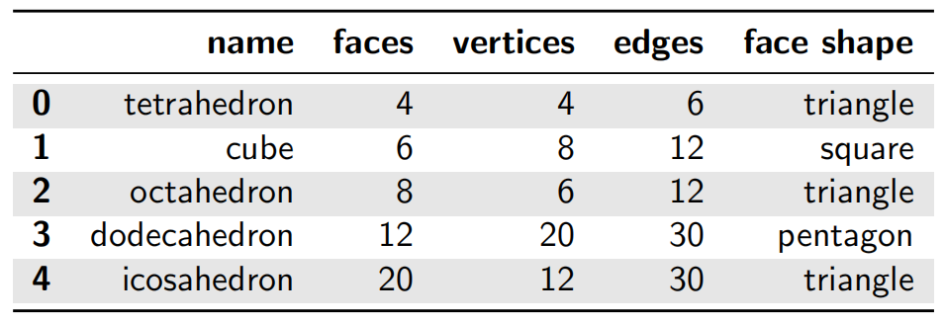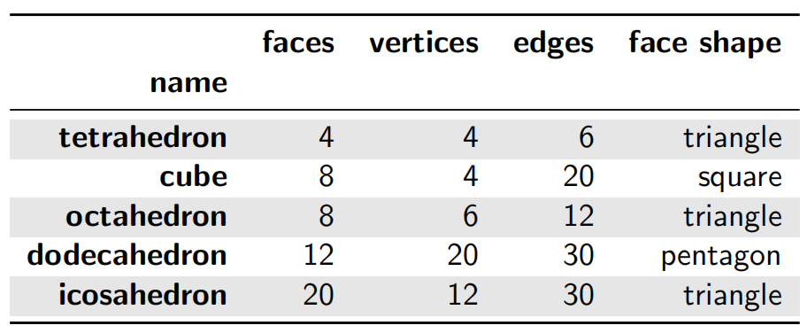
DF = DF.set_index(Key1) # 将Key1的List_of_Content1当成列索引(右)

通过csv文件读取Dataframe
DF = pd.read_csv(Document_Name, index_col = Key1))
DF.head()

我们可以使用DF[index]以提取/修改/添加Dataframe的某一列, 或者对列与列进行运算
除此之外, 我们还有一些对于数据的操作指令
DF = DF.pct_change() # 将每一个的数据化成距前一项的百分比区别, 第一行数据为NaN
DF = DF.fillna(0)
DF = DF.astype(int)
DF = DF.cumsum()
DF = DF.rolling(n).mean() # 得到每一项与前(n-1)项数据的总平均值, 前(n-1)行数据为NaN
DF = DF.aggregate(['sum','mean']) # 只得到两行: 每列数据的sum与mean

DF.index = pd.to_datetime(DF.index) # 将行索引转化为时间格式
DF = DF.resample('A').sum() # 如果行索引是时间格式, 将其按照要求重新整合
# 关键词有 ‘A’ (for annually), ‘6M’ (for six months), ‘2H‘ (for two hours), ‘20min’, ’10S’
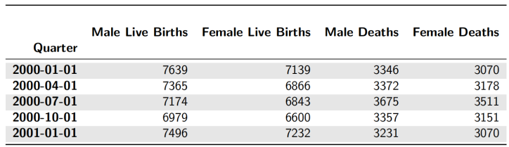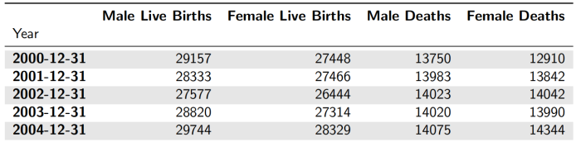

DF.index = DF.index.rename(New_Key1) # 改变行索引的索引的名称
DF = DF.rename(index=[New_Index1,New_Index2,...]) # 改变行索引的名称
DF = DF.rename(columns=[New_Index1,New_Index2,...]) # 改变列索引的名称

以下为一些有关于Dataframe的画图方式. 注意画图的时候可以关于Dataframe整体画图, 也可以关于某几列画图
DF.plot(), DF.plot.bar(), DF.plot.hist(), DF.plot.box()
DF.plot.scatter(x=KeyA,y=KeyB)

以下为一些有关于Dataframe的计算方式.
DF.count(), DF.mean(), DF.median(), DF.std(), DF.quantile(0.25), DF.quantile(0.75), DF.max(), DF.min()
DF.describe() # 用一个表格展示上述所有数据

通过querying, 我们只关注满足Statement的信息. 这种情况下无需写DF[KeyA] > ..., 直接写‘KeyA > ...’即可
DF.query(Statement)

the basic idea of a pivot table is this: we’ve got a flat table with at least two columns, c1 and c2, and let’s say c1 contains a number of repeats; the column c2 would usually (though not always) contain numerical data.
我们想要根据c1的不同类别进行数据的整理, 并可以根据c3进行进一步地细分(但是如果没有细分项会输出NAN)
DF1 = DF.pivot_table(index=Key_c1, values=Key_c2, aggfunc='sum', type=Key_c3)
# 这里的aggfunc可以是'sum', 'mean', 'count', 'first', 'last', 'min', 'max' and 'std'
# You can also use a named function or a lambda-expression
DF2 = DF.groupby(List_of_Keys)[List_of_Keys].mean()
# method可以更改. groupby的作用与pivot_table类似, 只是groupby支持用List_of_Keys进行分类

